SUPPORTING A CHILD RETURNING TO SCHOOL AFTER LOCKDOWN

After being off school for so long, it’s only natural that many young people will be worried about returning to school.
Here are some tips from our Parents Helpline team on how you can support your child to transition back to school life:

Source: Supporting a child returning to school after lockdown (youngminds.org.uk)
Exploring Feelings
For younger children, parents can use stories to explore feelings about going back to school. For example, the Little Elf story https://em-edsupport.org.uk/Page/7730 or other stories on https://www.littleparachutes.com/

SUPPORTING A CHILD RETURNING TO SCHOOL AFTER LOCKDOWN
Practical Tips
Preparing children for changes
It might be helpful for parents and teachers to prepare children ahead of school starting that school may feel different (e.g. through newsletters). Classes may be smaller, they may have to wash their hands more, they may have less close contact with friends at school and stick to small groups of friends. All of this is to help keep them safe.

Modelling Calmness
You will probably have your own worries about your child going back to school. Try to be aware of how you model your own anxiety when speaking to your child about returning to school. Speak to your child when you feel calm yourself.

Focus on possible strategies
Help children to focus on possible strategies. Ask them how they changed to the lockdown. What helped? What might help them now adapt to going back to school?
Try and problem solve concerns that can be resolved now e.g. contacting a friend if your child is worried that their friends won’t speak to them at school.

Limit reassurance to encourage a growth mindset.
Help children to recognise that building tolerance of uncertainty can help them manage their anxiety and develop their growth mindset. It is like building up ‘mind muscles'. Limit reassurance as this can maintain anxiety. Instead encourage children to ask questions, and support skills in problem solving so they can consider their own solutions.

Normalising
It is also normal to feel very anxious about the changes. Change makes most people feel a bit worried. Some people find this harder than others though.

Uncertainty
This is a very uncertain time and we can’t make COVID disappear (not yet anyway). Children, like us adults, must learn to tolerate some uncertainty. This skill can help us to manage anxiety.

Rewards
Use rewards in and out of school to help children manage their anxiety about getting to school and managing at school. This should be age appropriate and not too expensive.

Worry box and time
Have a worry box and post worries in this through the day. You can agree a deferred time to talk through their worries. This can help contain worries.

Uncertainty & Change
SUPPORTING A CHILD RETURNING TO SCHOOL AFTER LOCKDOWN

Preparing for Return
Listening
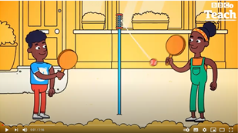
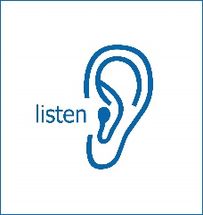
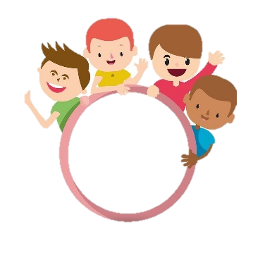
References
Website - Returning to School After The Lockdown - Nip in the Bud
Face Sheet - Supporting-Children-Returning-to-School-After-the-Lockdown.pdf
YouTube - Tips Returning To School - YouTube

Helpful Video: Coronavirus: Back to School for Primary Schools (BBC Teach)

After returning to school make new routines fun where possible
In school, be clear about the new routines so that children have some sense of control. Help to make routines fun for example singing songs to washing hands

Listening to each other
Teachers should listen to children and not assume how they feel or what they have gone through.
Help children to listen to each other too so they can process the huge changes. It is important to not ignore the changes that have occurred.

This Photo by Unknown Author is licensed under CC BY

More contact before schools re-open for teachers and families
Encourage children to share their work with school and teachers may arrange phone calls with families if possible, especially where anxieties are known. Some primary schools have Mental Health Support Teams or counsellors and it may help to run anxiety groups or transition groups for anxious children or their parents before returning to school.

Listening and validating
Listen to your child. Hear what their concerns are. Acknowledge their feelings and let them know that you know it’s tough for them
We don’t have all the answers
It’s ok to not have the answers. In fact, it’s better not to pretend that you know. We don’t know. It’s possible we may move back to school, then to lockdown, and back. This could go on for a while
Parents preparing children for the return
Before returning to school, try and prepare children by getting them back into a routine. E.g. establishing bedtime/morning routines. They could do some practice runs to school beforehand. If they are not already doing so, help them to reconnect with friends to make the transition easier. They can meet with one friend in a park or via zoom etc.

SUPPORTING A CHILD RETURNING TO SCHOOL AFTER LOCKDOWN

Supporting your child’s return to school | TheSchoolRun
If your child is going back to school after a period of home-schooling at home, it’s natural for you both to be nervous. Read our top tips for easing the transition back to the classroom. As soon as you know what day they will be back in the classroom, tell them when they'll be returning to school.
Find a quiet time with no distractions, and explain calmly, without any bias from your own opinions and feelings, why it’s now considered safe to go back to school.
The evidence on which the government is basing its decisions is that the risk of children becoming ill with coronavirus is far smaller than benefits of being back in school.
If your child has any worries about going back to school, a visual calendar or timetable can help to ease their anxiety.
Preparing your child like this will provide a sense of predictability and security, and counteract any feelings of uncertainty and disruption they may have experienced while learning at home.
If you have more than one child, you may need to make one calendar for each, especially if they’re returning at different times because of different self-isolation schedules
It’s natural for your child to feel sad, worried, cross or overexcited about going back to school and reconnecting with their classmates and teacher, and this could affect their behaviour, for example with tears or angry outbursts.
If your child is struggling with big feelings, try to stay calm and name their emotions out loud so they know you’re listening: for example, ‘I can see that you’re feeling angry at the moment.’
Learning to be an active listener without imposing any judgements or trying to ‘fix’ the problem is a real skill and will be hugely beneficial to your child both now and into the future.
Top tips for being an active listener
At this time of uncertainty, it’s important to be a good listener to your child so they feel they can talk to you about their feelings. Try these steps to becoming an active listener.
- Turn devices off to show that you’re listening.
- Squat down to the same level as your child and maintain eye contact. Be aware, though, that older children and teenagers often don’t like eye contact.
- Smile and use a gentle tone of voice.
- Try to avoid impatient body language like eye rolling, foot tapping or sighing. This can discourage children from talking.
- Put your own thoughts and feelings to one side.
- Allow your child space to talk without interrupting or contradicting them.
- Don’t be afraid of silence if your child is using it to reflect and think, but step in if the silence feels uncomfortable.
- Find encouraging things to say, like ‘Tell me more,’ ‘And then?’ and ‘Go on, what else?

SUPPORTING A CHILD RETURNING TO SCHOOL AFTER LOCKDOWN

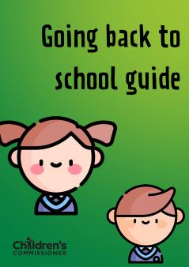
The Children's Commissioner's free, downloadable ‘Going back to school guide’ for kids offers tips to help children cope if they’re feeling worried.
Keep talking about the changes after they're back in the classroom to discover if they’re causing your child any anxiety.
If your child is very anxious about returning to school after a period of home-schooling, ask their school if they could have some brief contact with their teacher before they go back. It could be a phone call, email, letter, online meeting or recorded video message.
If your child has had a particularly difficult time, it may be helpful to have a catch-up call with their teacher about their experiences, so they understand their specific needs and behaviours.
This will help the teacher support your child with any issues that may have arisen during the break from school, particularly if they’ve had a difficult experience, such as a bereavement due to coronavirus child feel in control
Giving your child as much control as possible over the new school routine can help them feel more grounded.
You could, for example, ask your child to choose what they’d like in their lunchbox each day, or go online stationery shopping and let them decide what they'd like to buy: many schools are requesting that children have their own basic supplies so equipment doesn't have to be shared.
This can give them a sense of control and ownership over their return to school.
Parent Club: Advice on how to support your child returning to school with head teacher Kevin Brack - YouTube
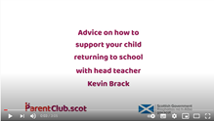

SUPPORTING A CHILD RETURNING TO SCHOOL AFTER LOCKDOWN

Looking After Your Own Wellbeing
While supporting your child, it’s so important to remember to look after your own mental health and ask for help from your support network or services when needed.
The NHS website (https://www.nhs.uk/conditions/stress-anxiety-depression/) has some good resources and clear links.

