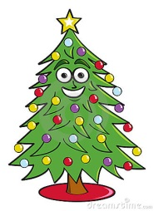
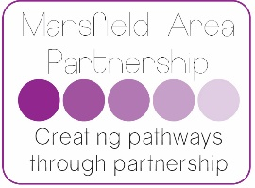
Surviving Christmas
for children with Social and Emotional Needs
consider: comments / actions :
Is Christmas a positive memory / experience? Are there issues you need to be mindful of?
Do you know what Christmas is like for this child? What takes place? What traditions / events will take place at home? Where? Who with?
Does this child know what will happen in school? Do not assume that children will remember each year – take time to explain. Would a diary / calendar help?
How will the school environment change in school and at home? Consider classroom/hall/corridor/other spaces?
How will routines change? Consider everyday routines e.g. opening advent calendars/school post box/ rehearsals/ timetable changes/ lesson changes
Will availability of staff change at all on specific days? When? Does the child know in advance? What are the plans needed?

If children are involved in ‘special’ activities or jobs can they cope with this e.g. handing out Christmas cards/ parts in the play
How can we support this?
When planning special events consider which parts will this chid enjoy / dislike?
How do we make it a success? Which bits might be tricky?
What is the ‘emergency’ plan? Where will they sit? Who with? What distraction / strategies can adults use?
Are they getting enough sleep / relaxation/ calm time at home? School? Do we need to increase this in school for a few weeks?
Is there a calm ‘Christmas free zone’ in school for children (or staff!!) to access?
What sensory sensitivity issues might need to be considered?
A few of the sensory experiences that may need to be considered:
- Lights/tinsel on trees
- Smell of trees
- Hanging decorations/ paper chains
- Noise of rehearsals (more singing at Christmas than any other time of year!)
- Sitting for periods of time in rehearsals – comfort, closeness to others
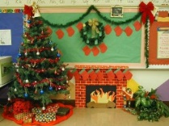
- Change in appearance of environment / furniture moving
can be visually distracting
- Smell of Christmas dinner
- Wearing a costume
- Noise of party music and excited children
- Santa!!
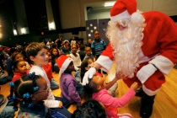
- Crackers, crackly party hats
- Discos – noise, heat, closeness of other people
- Party games

Have a very Happy, calm and Peaceful Christmas from all at the Mansfield Area Partnership
